1349-CPD-014
06
EN 13361, EN 13362, EN 13491,
EN 13492, EN 13493

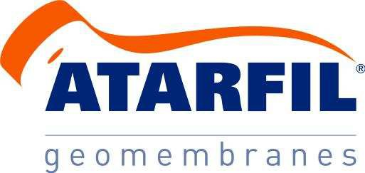

ATARFIL LLD
Raw Material
Linear Low Density Polyethylene

ATARFIL LLD is a geomembrane manufactured from maximum quality linear low density polyethylene LLDPE resins, duly contrasted, that comply with the most rigourous requirements established for their use.

ATARFIL LLD contains 97,5% of pure polymer, and approximately 2,5% of Carbon Black, antioxidants and thermal stabilizers. The product does not contain plasticizers or fillers that can migrate over time.

The geomembrane ATARFIL LLD is manufactured under permanent quality controls.
Surface
Raw Material Identification
Durability
Functional Properties
Tested Property Unit Test Method Value
Low Temperature Brittleness (tª: -40ºC) | - | UNE EN 495-5 | No cracks
Water Permeability | m³/m²·day | UNE EN 14150 | < 1·10 ⁻⁶
Coefficient of Linear Thermal Expansion | 1/ºK | ASTM D 696 | 1,93·10 ⁻⁴
Water Absorption | % | UNE EN ISO 62 (24h) | ≤ 0,1
Water Absorption | % | UNE EN ISO 62 (6  days) | ≤ 0,5
Thickness of Coextruded Layer | % | UNE EN 53213-2 | -
Asperity Height | mm | GRI GM 12 | -

Oxidative Induction  Time (OIT) | min | UNE EN 728 (200ºC) | > 100
Stress Crack Resistance/NCTL | h | ASTM D 5397 | > 300
Oxidation | % | UNE EN 14575 | ≤ 15

Smooth | Colour  RAL Code | Black
 | Colour  RAL Code | -
Tested Property Unit Test Method Value
Density of Raw  Material | g/cm³ | UNE EN ISO 1183-1 | < 0,932
Density of  Geomembrane | g/cm³ | UNE EN ISO 1183-1 | ≤ 0,940
Melt Flow Index | g/10 min | UNE EN ISO 1133 D  Condition (190ºC/2,16 Kg) | ≤ 1,2
Melt Flow Index | g/10 min | UNE EN ISO 1133 T  Condition (190ºC/5 Kg) | ≤ 3,5
Carbon Black  content | % | ASTM D 4218 | 2,0 - 2,5

Thickness | mm | UNE EN 1849-2 | 1.00 | 1.50 | 2.00 | 2.50 | 3.00
Confidence level 95% | % | - | Tolerance: ± 6
Confidence level 90% | % | - | Tolerance: ± 4
Tensile Properties (*)
Tensile strenth at Break | N/mm | UNE-EN ISO 527  (Type V) | 31 (26) | 46 (39) | 62 (52) | 77 (65) | 93 (78)
Elongation at Break | % | UNE-EN ISO 527  (Type V) | 800 (≥750)
Tear Resistance | N | ISO 34-1 | ≥ 100 | ≥ 150 | ≥ 200 | ≥ 250 | ≥ 300
Puncture Resistance | KN | UNE-EN ISO 12236 | 2.50 | 3.00 | 4.50 | 5.00 | 6.00
Exploding Resistance | % | pr EN 14151 | < 15
Dimensional Stability | % | UNE EN ISO 14632 (100ºC, 1h) | ± 1,5

Parameter | Units | 1,00 | 1,50 | 2,00 | 2,50 | 3,00
Roll width | m | 6 | 6 | 6 | 6 | 6
Roll Length | m | 210 | 140 | 105 | 84 | 70
Surface | m2 | 1260 | 840 | 630 | 504 | 420
(*) Values indicated are medium. In brackets values with 95% confidence level.
Tested Property
Unit
Test Method
Value
PRESENTATION
(Standard Sizes)
Strength Characteristics Quality of Final Product
90708

This information is provided for reference purposes and is not intended as guarantee. ATARFIL assumes no liability in connection with the use of this information or the final use of the product.
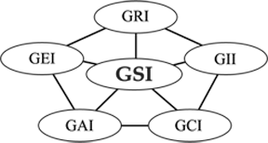

Headquarters: Ctra. de Córdoba, Km 429 - Complejo El Rey – E-18230 Atarfe – GRANADA – SPAIN – Tel.: +34 958 439 200 – Fax: +34 958 439 128 – www.atarfil.com

